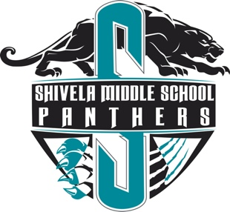
SHIVELA MIDDLE SCHOOL
Ms. Spencer’s Class Policy

SHIVELA MIDDLE SCHOOL

DIGITAL CITIZEN AGREEMENT

SHIVELA MIDDLE SCHOOL 2022-2023
Welcome to Ms. Spencer’s sixth grade Math and Science class My goal for your child this year is to help him/her learn and progress to the best of his/her abilities. I want each child to be able to give and receive help when it is necessary and to be able to accept responsibility and the resulting consequences for his/her behavior. I believe these goals can be accomplished with your support. I truly believe that students have a right to learn, and teachers have the privilege and right to teach.

Please email me at sspencer@murrieta.k12.ca.us if you have any questions or concerns

LIVING THE PANTHER LIFE BY
To be a responsible learner I will:  - Listen attentively, ask questions, and follow directions  - Respect the learning of others by remaining on-task  - Model exemplary work habits  - Demonstrate a desire for lifelong learning everyday | To have integrity I will:  - Be patient with others, including students and adults  - Accept consequences for behavior & respond appropriately  - Ensure all interactions online are the best representation of you  - Ensure the correct use of other’s materials follow
To be a good friend I will:  - Show respect and empathy to other  - Develop the habits of compassion and forgiveness  - Foster positive relationships  - Contribute to a fair and just school environment | To show excellence at School I will:  - Strive to do your best  - Chart a path to success  - Accept rigorous challenges  - Persevere when faced with adversity
CLASSROOM BEHAVIOR POLICY
In the classroom:
- “Treat others as you want to be treated” -Golden Rule
- Be on time to class, prepared, and ready to learn
- I will enter the classroom: no gum, cell phone away in backpack, hoodies off head
- Respect yourself, others, and adults
- Stay in seat before bell rings: the teacher will dismiss the classroom
- Be safe and understand all classroom rules

HOMEWORK/LATE WORK POLICY | GRADING POLICIES
- Assignments are expected to be turned in complete and on time.  - No Late Work is accepted after chapter test  - Any late work earns half credit | Of Your Grade:  - 80% Assessments/Projects  - 20% Homework/Practice  - All Tests and Projects earning less than 50% are marked as 49.99

Big Ideas Math: This is the student’s main Math textbook with an online homework component. Homework answers will be submitted online to the Big Ideas Website. ALL work will be done in their spiral notebook and kept in the notebook. The consumable workbook will be kept inside the classroom.

Imagine Math: This is the student’s supplemental resource. It will be used in the classroom/home.

STEMscopes: This is the student’s main science digital/workbook curriculum. Work will be done in spiral notebook, workbook, or STEMscopes website.

CANVAS: Please become familiar with your course Canvas pages. Please check the site regularly for homework assignments, assessments, and updated grades.

